**Project Design Phase-II**

**Data Flow Diagram & User Stories**

|  |  |
| --- | --- |
| Date | 24 JUNE 2025 |
| Team ID | LTVIP2025TMID49893 |
| Project Name | Visualizing Housing Market Trends: Analysis Of Sale Prices And Feature Using Tableau |
| Maximum Marks | 4 Marks |

**Data Flow Diagrams:**

A Data Flow Diagram (DFD) is a traditional visual representation of the information flows within a system. A neat and clear DFD can depict the right amount of the system requirement graphically. It shows how data enters and leaves the system, what changes the information, and where data is stored.

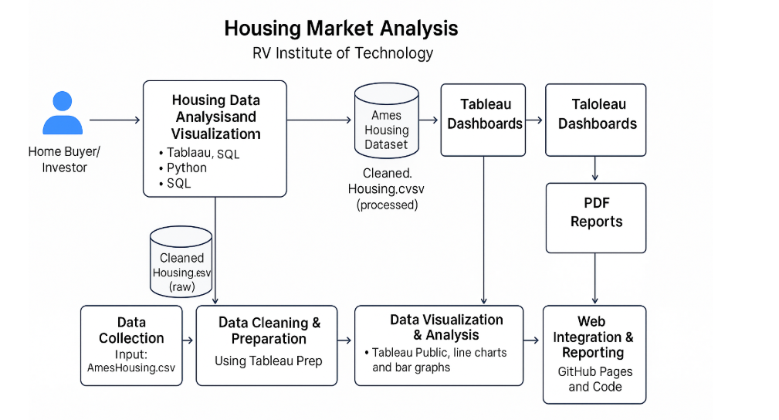

**User Stories**

Use the below template to list all the user stories for the product.

| **User Type** | **Functional Requirement (Epic)** | **User Story Number** | **User Story / Task** | **Acceptance criteria** | **Priority** | **Release** |
| --- | --- | --- | --- | --- | --- | --- |
| Customer (Buyer/Seller) | Data Visualization Access | USN-1 | As a user, I can view dashboards showing average house prices over years. | I can access and interpret price trends clearly. | High | Sprint-1 |
|  |  | USN-2 | As a user, I can filter data based on house age, renovation status, and location. | I can apply filters and see updated visualizations. | High | Sprint-1 |
|  | |  | | --- | |  |  |  | | --- | | Dashboard Interaction | | USN-3 | As a user, I can download reports or snapshots of dashboards for offline analysis. | As a user, I can download reports or snapshots of dashboards for offline analysis. | Medium | Sprint-2 |
|  | Dashboard Interaction | USN-4 | As a user, I can embed interactive dashboards into other platforms or websites. | Embedded dashboards work and are interactive. | Low | Sprint-2 |
| Data Analyst (Web User) | Data Preparation | USN-5 | As an analyst, I can upload cleaned data for visualizations. | Data uploads without errors and reflects in dashboards. | High | Sprint-1 |
|  | Data Analysis | USN-6 | As an analyst, I can perform performance testing and view data load metrics. | I can see data size and confirm smooth rendering. | Medium | Sprint-2 |
| Administrator | User Management | USN-7 | As an admin, I can manage user access to dashboards and stories. | I can grant or revoke access permissions. | High | Sprint-1 |
| Administrator | Monitoring & Reports | USN-8 | As an admin, I can track publishing history and monitor dashboard usage statistics. | I can generate and download usage reports. | Medium | Sprint-2 |